**Description:**

Creating a mobile application to capture gesture movement and face recognition to compare them with test samples. These test samples will be saved beforehand on the mobile phone or created during the test.

Comparing the captured data with the sample will result into either a number or a word. This will be converted to a command to perform.

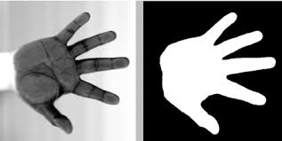

eg. 5 fingers + sample = '5' / 'open'

**How it works**

* Using Android Studio
* SDK version 26
* Downloaded the latest CVlibrary to be used (3.4.1)
* - For Gesture, Face recognition and needed libraries
* Dependency on CVlibrary with the mobile application
* Created jniLibs folder to store the libraries necessary
* NDK was set up using the Link c++ method instead of using the 'gradle.properties' and setting it to true from there (no longer supported)
* created an opencv.java for implementing the face detection sequence

**Results**

* The app is running and the camera is operating as it should
* However, the problem is the face detection software is not functioning properly either because of the latest version of the CVLibrary(3.4.1) or because of the mobile phone
* A sample of face detection Application 'OCV Face Detection.apk' from the CVlibrary (which they come included with the libraries), was installed directly to my phone to test whether or not the problem is either coming from the code or not. It turns out that the application had the same result as my application.

(The apk was included ‘example-face-detection.apk’)